Geometry: Unit 7, Lesson 7
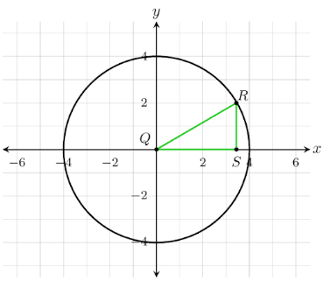
- The unit circle is shown where $∆QSR$ is a right triangle and $m∠RQS=30°$. If $∠RQS$ is the reference angle, what is the cosine of $∠Q$?

$$\frac{QS}{QR}$$

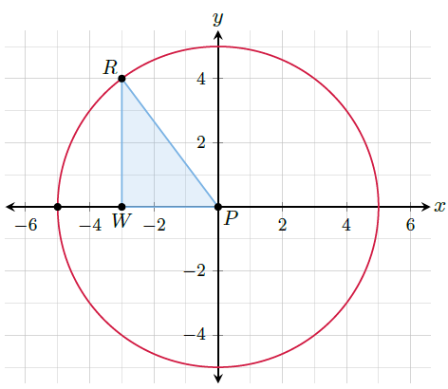

- A unit circle with radius of $5$ is shown where $∆PWR$ is a right triangle. What is the length of $\overline{PR}$, rounded to the nearest hundredth?

$$5.00$$
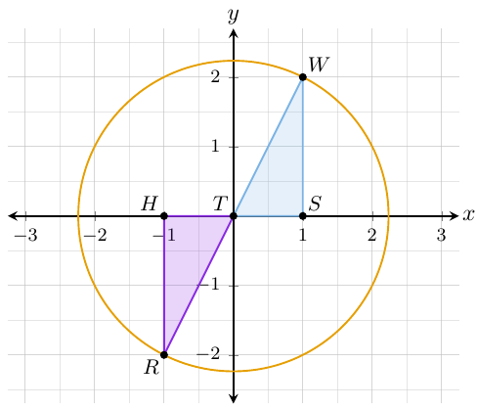
- Right triangles $WTS$ and $RTH$ are shown on the unit circle where $W$ is at $(1, 2)$. What are the coordinates of point $R$?

$$(-1, -2)$$

